How to install terraform on Ubuntu

1. Open Ubunu Server
2. Create new folder “terraform”

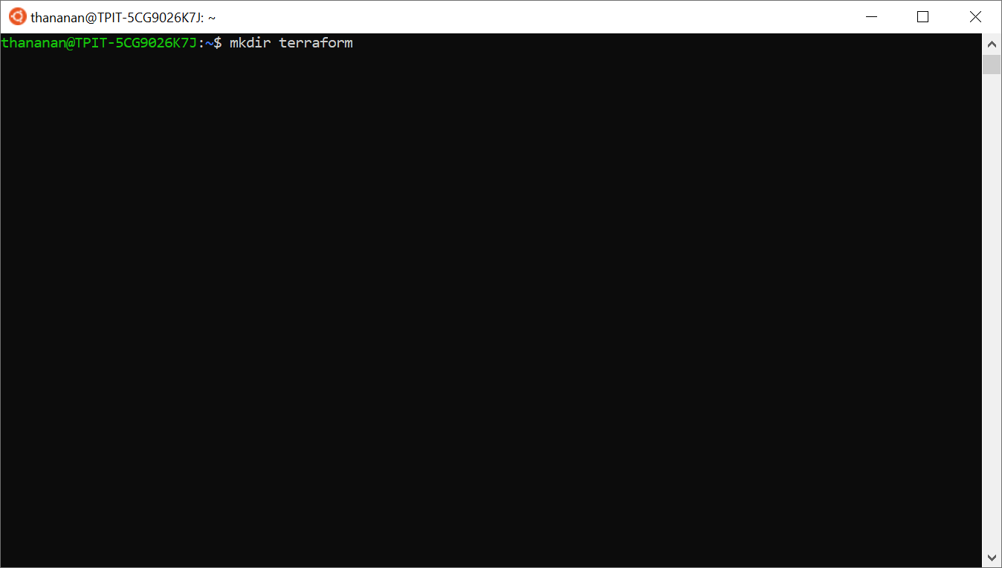

1. Access to directory “terraform”

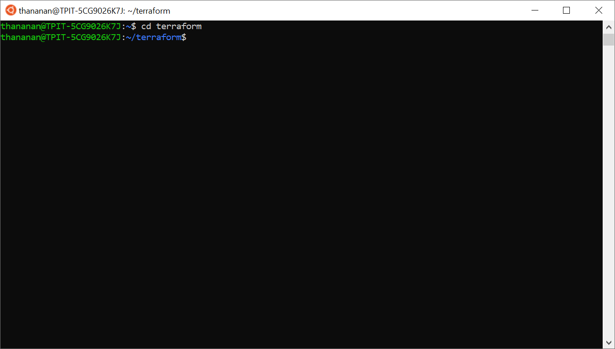

1. Download terraform package via download link as below;

“<https://releases.hashicorp.com/terraform/0.13.5/terraform_0.13.5_linux_amd64.zip>”

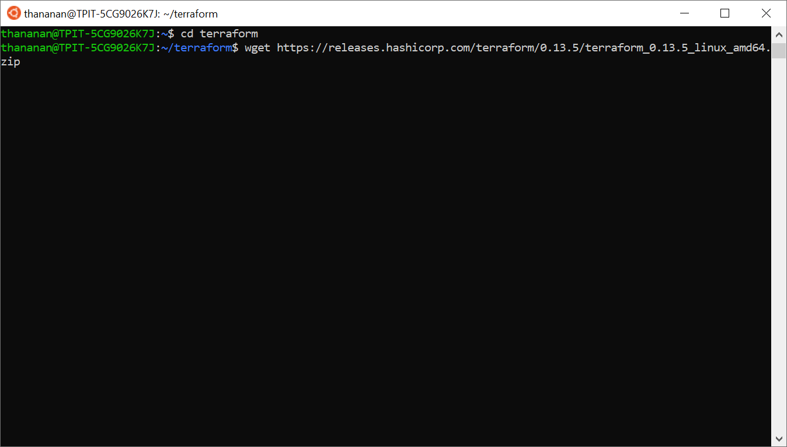

1. After finish download, unzip the package

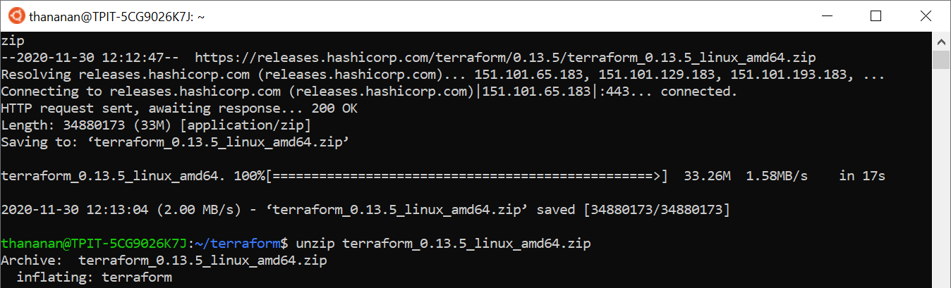

1. Access to file “profile” to add path to use for package installer

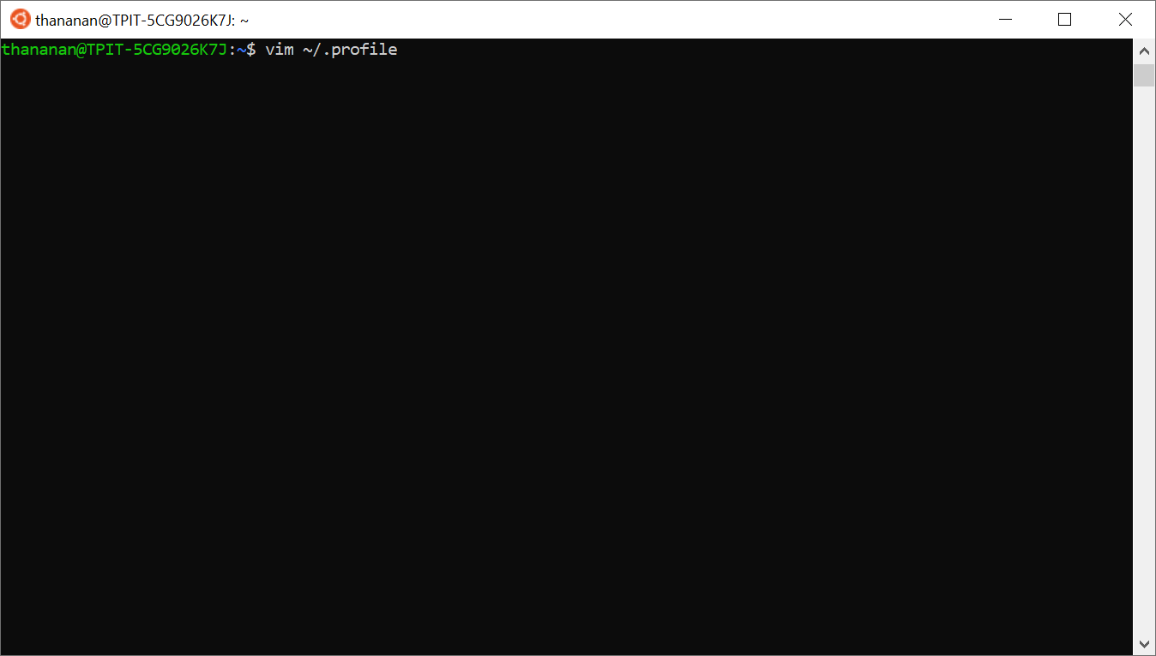

1. Insert path to run installer by adding PATH as below;

Type: export PATH=”$PATH:~/terraform”

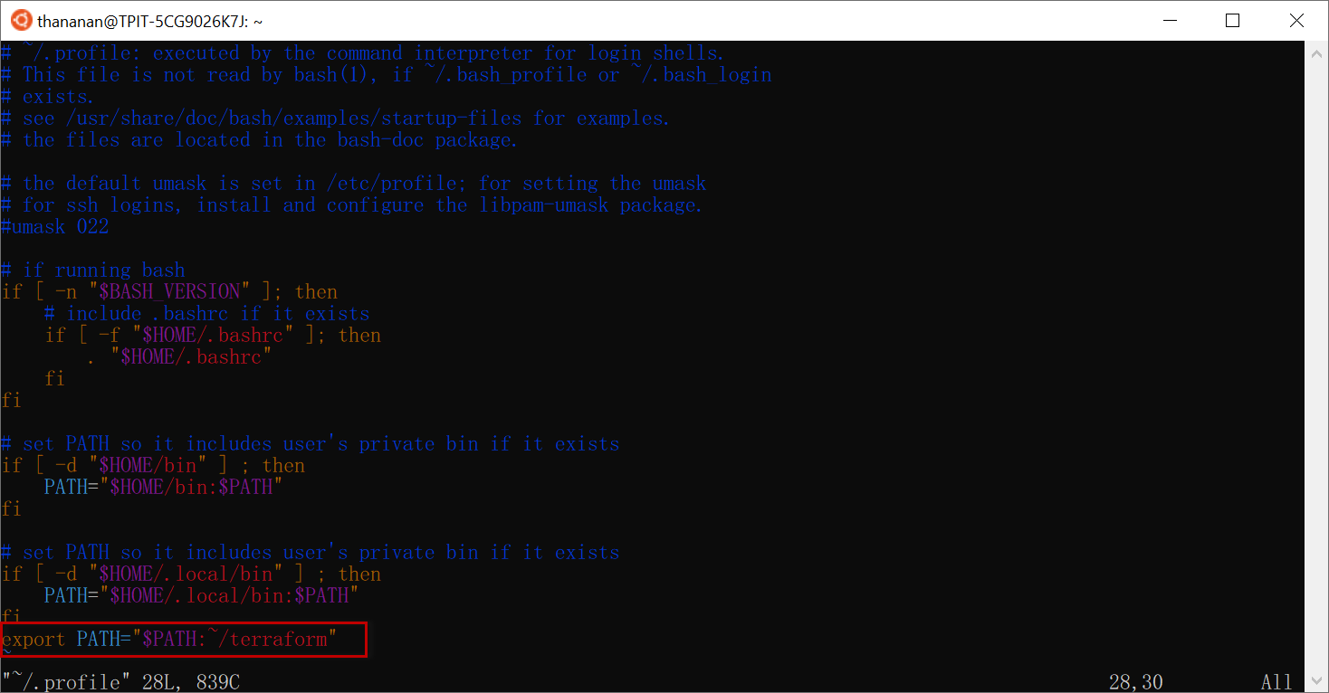

1. Run file profile

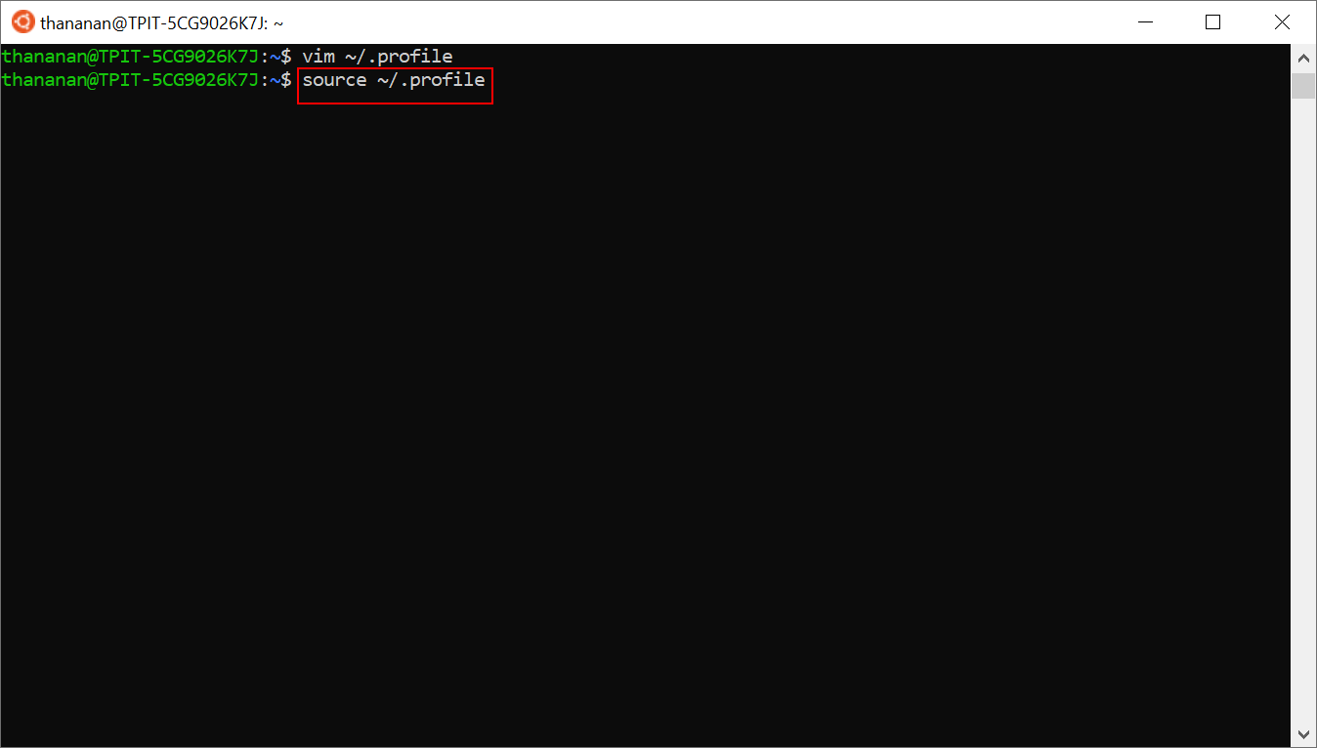

1. Check terraform version (This shows that terraform is installed successfully.)

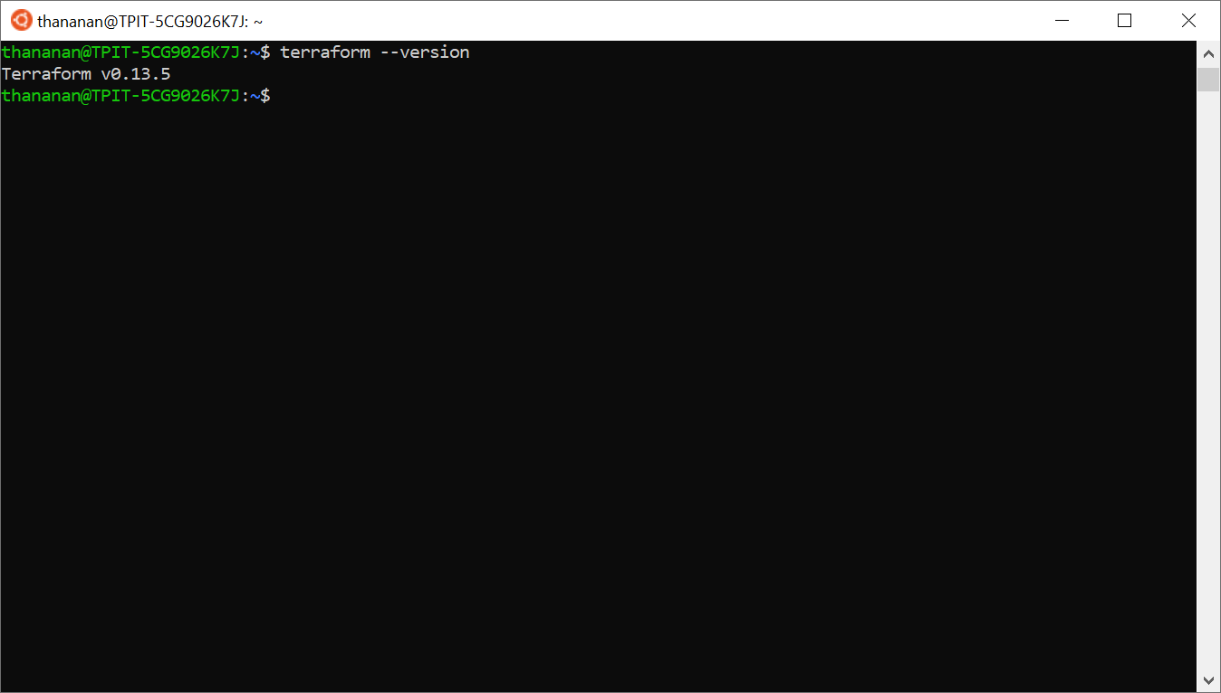

3.dfva